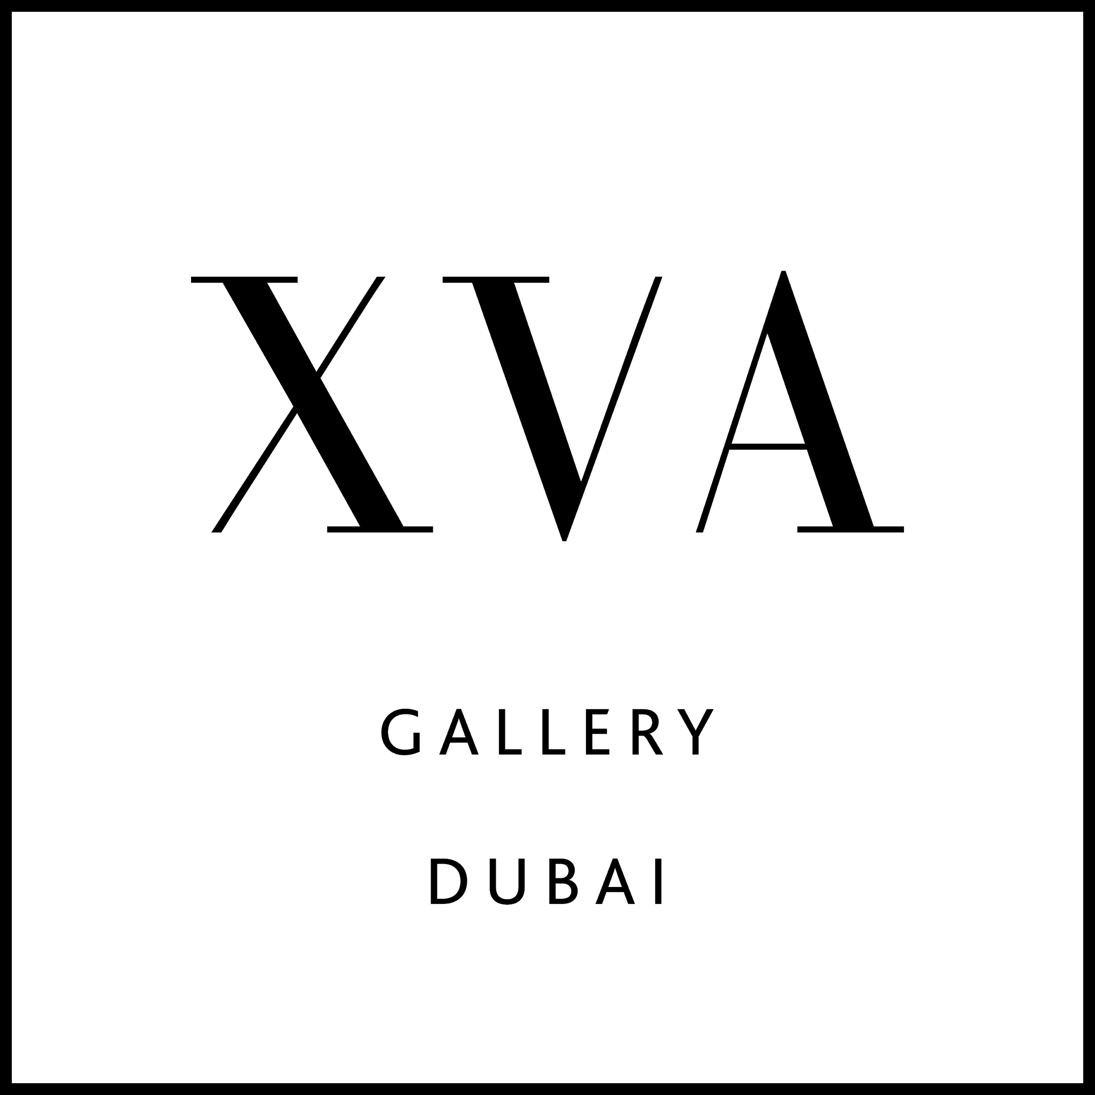

XVA Gallery presents 21st SUMMER, a solo exhibition, opening 21/06/2021

8th June 2021, Dubai, UAE // XVA Gallery is pleased to present 21st SUMMER, a solo exhibition by Nasr Warour.

Showcasing various works, including paintings, sculptures and photographs, this curated solo exhibition is a celebration of the 21 years the artist has spent in Dubai.

Born and raised in Syria, Nasr began his art studies in 1984 as a young schoolboy. With sculpture as his primary medium of expression he continued to hone his skills at the University of Damascus, moving away from home for the first time in 1986. He turned the space constraint into an opportunity, changing his medium to painting. His unique interpretations of the culture and history of his homeland led to the creation of many large-scale artworks setting him apart from his contemporaries.

Here in the UAE, his art and creativity flourished, winning him many accolades in recent years.

The exhibition timing is especially poignant as Nasr will be moving to his new home in the United States of America.

“10 years after moving to Dubai I showcased a review of my work at the Al Shamsi Art House in Sharjah. And today as I start a new chapter, I am grateful to be getting the opportunity to say thanks to a city that has been my home for 21 years with this second review. These formative years cannot be measured by time but by success, love, and peace.” - Nasr Warour

Exhibition Dates: 21st June - 21st July 2021

Established in 2003, XVA Gallery is one of the leading galleries in the Middle East that specializes in contemporary art from the Arab world and the Sub-continent. Exhibitions focus on works by the region’s foremost artists as well as those emerging onto the scene. The gallery’s artists express their different cultural identities and perspectives while challenging the viewer to drop prejudices and borders. XVA Gallery exhibits both locally and internationally; collaborating with galleries and participating in international art fairs, such as Art London, SH Contemporary and Art Basel Hong Kong in order to further expose Middle Eastern contemporary art.

FOR MORE INFORMATION CONTACT:
XVA Gallery
Grace Hauser
E: grace@xvagallery.com
E: xva@xvagallery.com
T: +9714 353 5383
M: +97150 322 5002

